**Scenario 3**

Task ::

In a Kubernetes cluster currently on version 1.27. elevate the master node's control plane and node elements to 1.27.

Note : Do not upgrade the slave worker nodes .

**solution**

To upgrade the master node's components:

1. First, plan the upgrade to see which components will be upgraded:

ssh k8s-master-node

kubectl drain k8s-master-node --ignore-daemonsets

kubectl get nodes

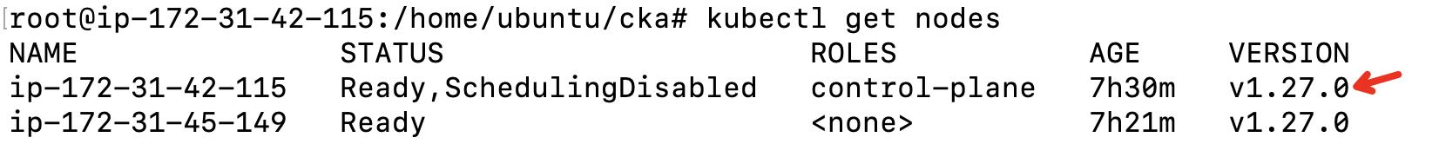

2. Upgrade the kubelet and kubectl on the master node:

sudo apt-get install -y kubeadm=1.27.6-00 kubelet=1.27.6-00 kubectl=1.27.6-00 --allow-change-held-packages

3. validate components are upgraded:

kubectl get nodes

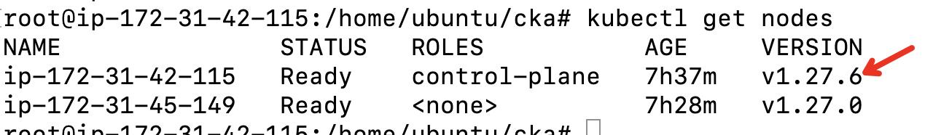

Ensure you have backups and have tested the upgrade process in a non-production environment before applying any changes to a production cluster.